Exercise 1: Ranking and Window Functions
Goal: Use ROW_NUMBER(), RANK(), DENSE_RANK(), OVER(), and PARTITION BY

Solution

CREATE TABLE products (
product_id INT PRIMARY KEY,
product_name VARCHAR(100),
category VARCHAR(50),
price DECIMAL(10, 2)
);

INSERT INTO products (product_id, product_name, category, price) VALUES
(1, 'Laptop A', 'Electronics', 1000.00),
(2, 'Laptop B', 'Electronics', 950.00),
(3, 'Laptop C', 'Electronics', 1000.00),
(4, 'Phone A', 'Electronics', 500.00),
(5, 'T-shirt A', 'Clothing', 30.00),
(6, 'T-shirt B', 'Clothing', 25.00),
(7, 'T-shirt C', 'Clothing', 30.00),
(8, 'Shoes A', 'Clothing', 60.00),
(9, 'Chair A', 'Furniture', 150.00),
(10, 'Table A', 'Furniture', 300.00),
(11, 'Sofa A', 'Furniture', 300.00),
(12, 'Lamp A', 'Furniture', 100.00);

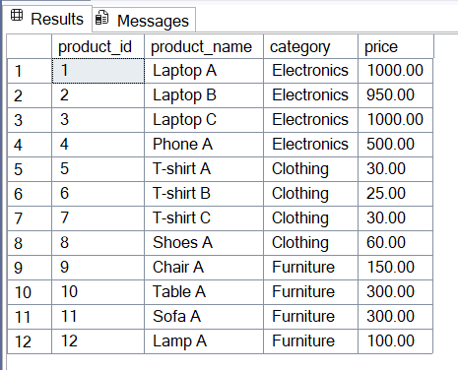

Find the top 3 most expensive products in each category using different ranking functions.

Steps:
1. Use ROW_NUMBER() to assign a unique rank within each category.

SELECT *
FROM (
SELECT *,
ROW_NUMBER() OVER (PARTITION BY category ORDER BY price DESC) AS row_num
FROM products
) AS ranked
WHERE row_num <= 3;

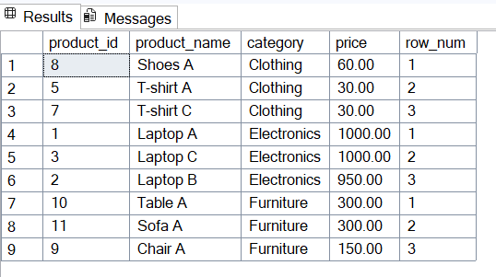

2.Use RANK() and DENSE_RANK() to compare how ties are handled

SELECT *
FROM (
SELECT *,
RANK() OVER (PARTITION BY category ORDER BY price DESC) AS rank_num
FROM products
) AS ranked
WHERE rank_num <= 3;

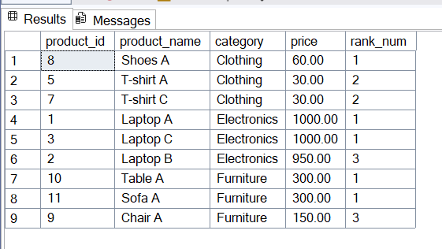

3.

SELECT *
FROM (
SELECT *,
DENSE_RANK() OVER (PARTITION BY category ORDER BY price DESC) AS dense_rank_num
FROM products
) AS ranked
WHERE dense_rank_num <= 3;

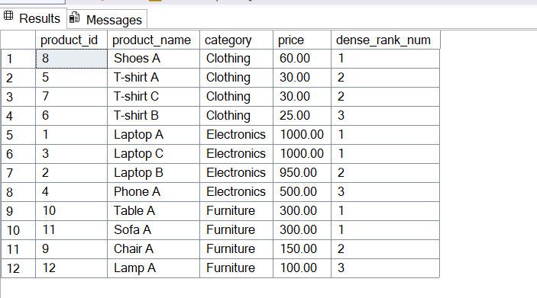

Stored Procedure

Exercise 1: Create a Stored Procedure
Goal: Create a stored procedure to retrieve employee details by department.
Steps:
1. Define the stored procedure with a parameter for DepartmentID.
2. Write the SQL query to select employee details based on the DepartmentID.
3. Create a stored procedure named `sp_InsertEmployee` with the following code

Solution

CREATE TABLE Departments (
DepartmentID INT PRIMARY KEY,
DepartmentName VARCHAR(100)
);

CREATE TABLE Employees (
EmployeeID INT PRIMARY KEY IDENTITY(1,1), -- Auto-increment ID
FirstName VARCHAR(50),
LastName VARCHAR(50),
DepartmentID INT FOREIGN KEY REFERENCES Departments(DepartmentID),
Salary DECIMAL(10,2),
JoinDate DATE
);

INSERT INTO Departments (DepartmentID, DepartmentName) VALUES
(1, 'HR'),
(2, 'Finance'),
(3, 'IT'),
(4, 'Marketing');

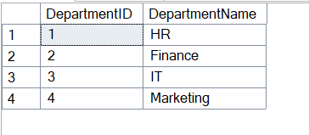

INSERT INTO Employees (FirstName, LastName, DepartmentID, Salary, JoinDate) VALUES
('John', 'Doe', 1, 5000.00, '2020-01-15'),
('Jane', 'Smith', 2, 6000.00, '2019-03-22'),
('Michael', 'Johnson', 3, 7000.00, '2018-07-30'),
('Emily', 'Davis', 4, 5500.00, '2021-11-05');

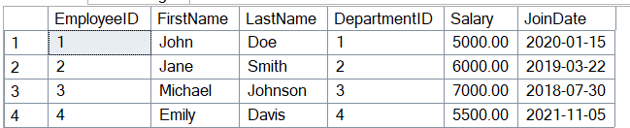

CREATE PROCEDURE sp_GetEmployeesByDepartment
@DeptID INT
AS
BEGIN
SELECT
e.EmployeeID,
e.FirstName,
e.LastName,
d.DepartmentName,
e.Salary,
e.JoinDate
FROM Employees e
INNER JOIN Departments d ON e.DepartmentID = d.DepartmentID
WHERE e.DepartmentID = @DeptID;
END;

EXEC sp_GetEmployeesByDepartment @DeptID = 1;

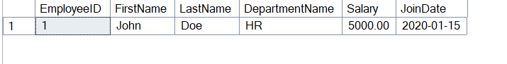

CREATE PROCEDURE sp_InsertEmployee
@FirstName VARCHAR(50),
@LastName VARCHAR(50),
@DepartmentID INT,
@Salary DECIMAL(10,2),
@JoinDate DATE
AS
BEGIN
INSERT INTO Employees (FirstName, LastName, DepartmentID, Salary, JoinDate)
VALUES (@FirstName, @LastName, @DepartmentID, @Salary, @JoinDate);
END;

EXEC sp_InsertEmployee
@FirstName = 'Robert',
@LastName = 'King',
@DepartmentID = 2,
@Salary = 6200.00,
@JoinDate = '2022-06-15';

Exercise 5: Return Data from a Stored Procedure
Goal: Create a stored procedure that returns the total number of employees in a
department.
Steps:
1. Define the stored procedure with a parameter for DepartmentID.
2. Write the SQL query to count the number of employees in the specified department.
3. Save the stored procedure by executing the Stored procedure content.

CREATE PROCEDURE sp_GetEmployeeCountByDepartment
@DepartmentID INT
AS
BEGIN
SELECT
COUNT(*) AS EmployeeCount
FROM
Employees
WHERE
DepartmentID = @DepartmentID;
END;

EXEC sp_GetEmployeeCountByDepartment @DepartmentID = 3;

